Final FastAPIs Report

Introduction
FastAPI is a modern, high-performance web framework for building APIs using Python. It is designed to create RESTful APIs quickly with minimal code while providing automatic interactive documentation through Swagger UI. FastAPI is widely used in Machine Learning projects because it allows trained models to be deployed as web services that can receive input data and return predictions in real time.
In this project, a Customer Lifetime Value (LTV) prediction model developed using Machine Learning was deployed using FastAPI. The API allows users to predict the Customer Lifetime Value for both a single customer and multiple customers through simple HTTP requests. This demonstrates how a Machine Learning model can be converted into a practical application that can be integrated into business systems.
Objectives
• To understand the concept of FastAPI and REST APIs.
• To deploy a trained Machine Learning model using FastAPI.
• To create a Home API endpoint to verify that the application is running successfully.
• To develop an API for predicting Customer Lifetime Value for a single customer.
• To develop an API for predicting Customer Lifetime Value for multiple customers simultaneously.
• To test the API using Swagger UI.
• To understand how Machine Learning models are deployed for real-world use.

FASTAPI SETUP
AIM
To set up the FastAPI framework and create the initial API application.
Procedure
The FastAPI library was installed along with Uvicorn, which is an ASGI server used to run FastAPI applications. A new Python file named main.py was created, and the FastAPI application object was initialized. A Home API endpoint was developed to verify that the application was working correctly. The application was then executed using the Uvicorn server and tested through both the browser and Swagger UI.
Code
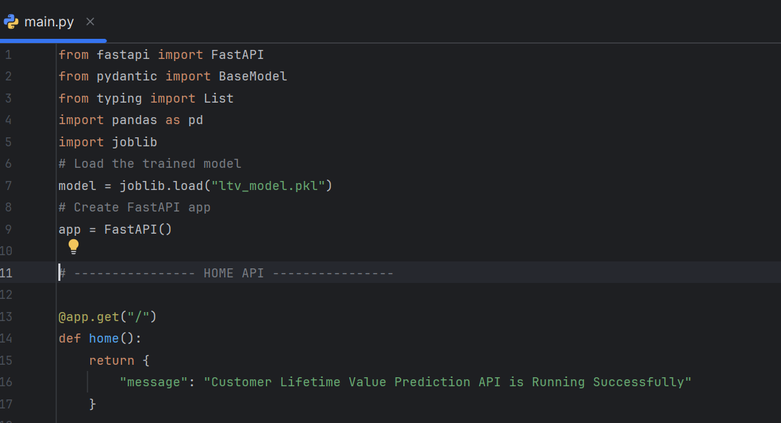
Output
The Home API successfully displayed the following response:
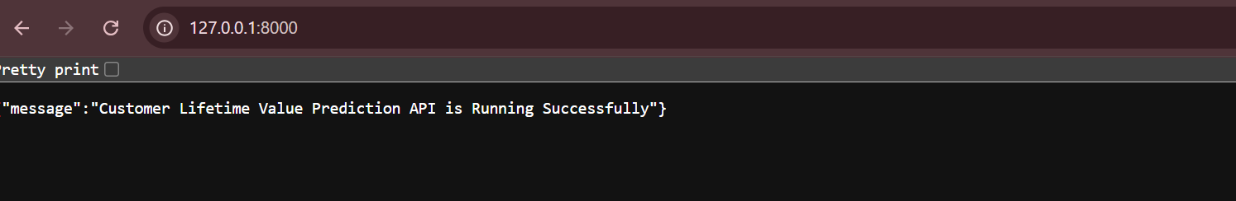

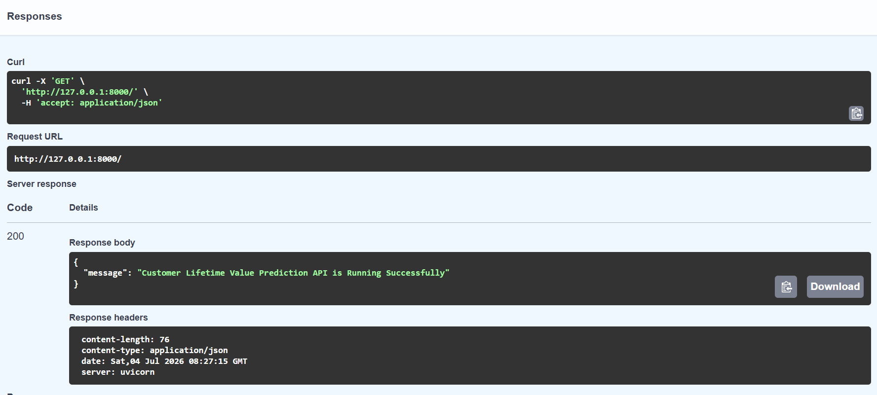

SINGLE CUSTOMER PREDICTION API
AIM
To develop an API endpoint that predicts the Customer Lifetime Value for a single customer.
Procedure
The trained Linear Regression model saved as ltv_model.pkl was loaded using the Joblib library. A customer data model was created using Pydantic to validate the incoming request. A POST /predict endpoint was developed to receive customer details in JSON format. The input data was converted into a Pandas DataFrame and passed to the trained model. The model generated the predicted Customer Lifetime Value, which was returned to the user as a JSON response.
Code
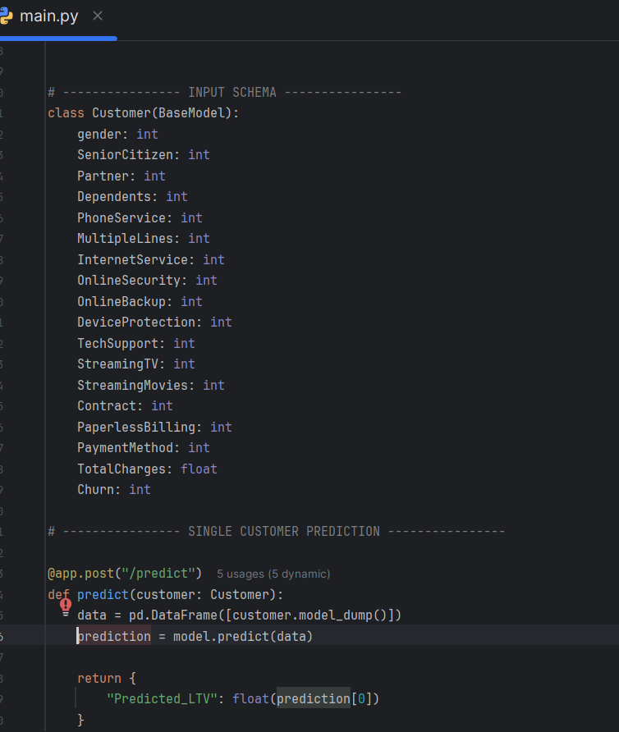

Output
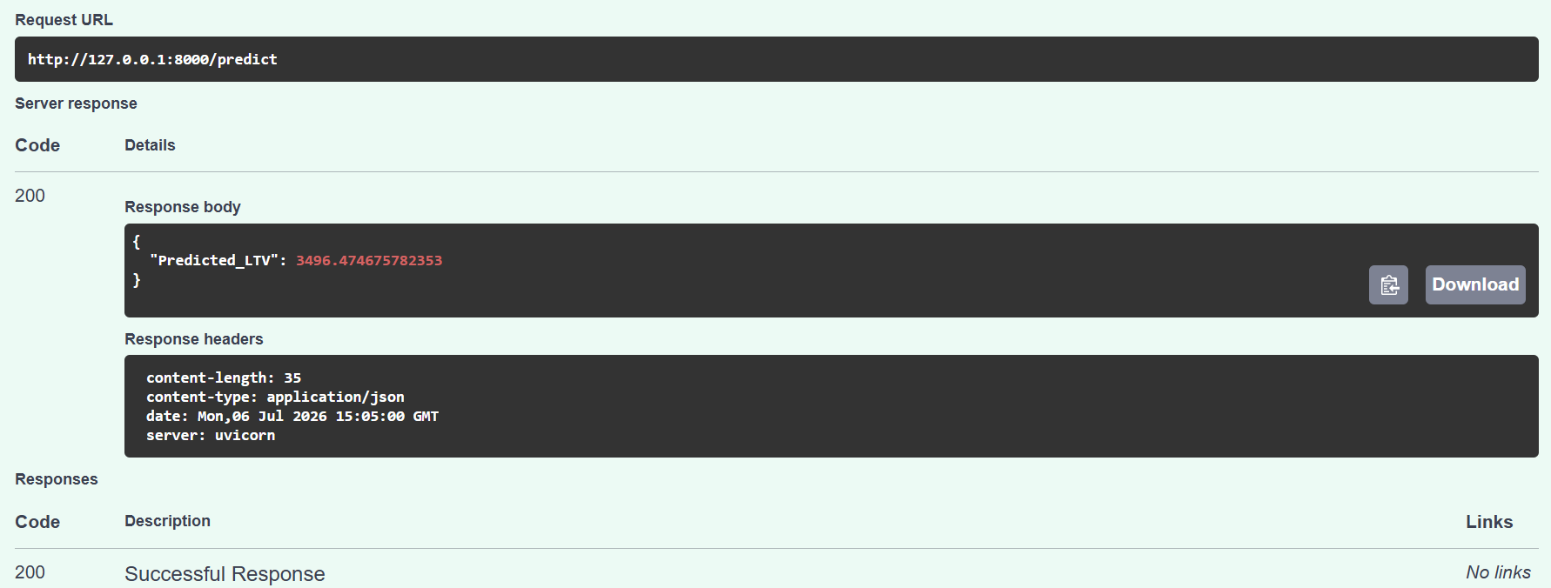
The Single Customer Prediction API was successfully executed using FastAPI. The customer details were provided as input in JSON format, and the API processed the data using the trained Linear Regression model. The API returned a Predicted Customer Lifetime Value (LTV) of 3496.47 with an HTTP 200 (Success) status code, indicating that the request was processed successfully. This result shows the estimated lifetime value that the customer is expected to generate based on the provided features, demonstrating that the deployed API is functioning correctly and can provide real-time LTV predictions.

BATCH PREDICTION API
AIM
To develop an API endpoint capable of predicting Customer Lifetime Value for multiple customers simultaneously.
Procedure
The Batch Prediction API was created using the POST /batch_predict endpoint. The endpoint accepts a list of customer records in JSON format. Each record is converted into a Pandas DataFrame, and the trained Linear Regression model predicts the Customer Lifetime Value for every customer in the batch. The predicted values are returned as a list in JSON format.
Code
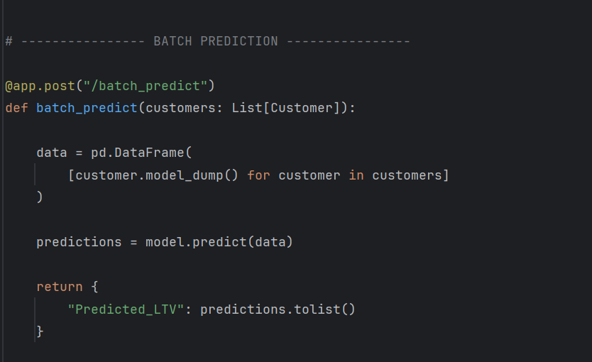

Output
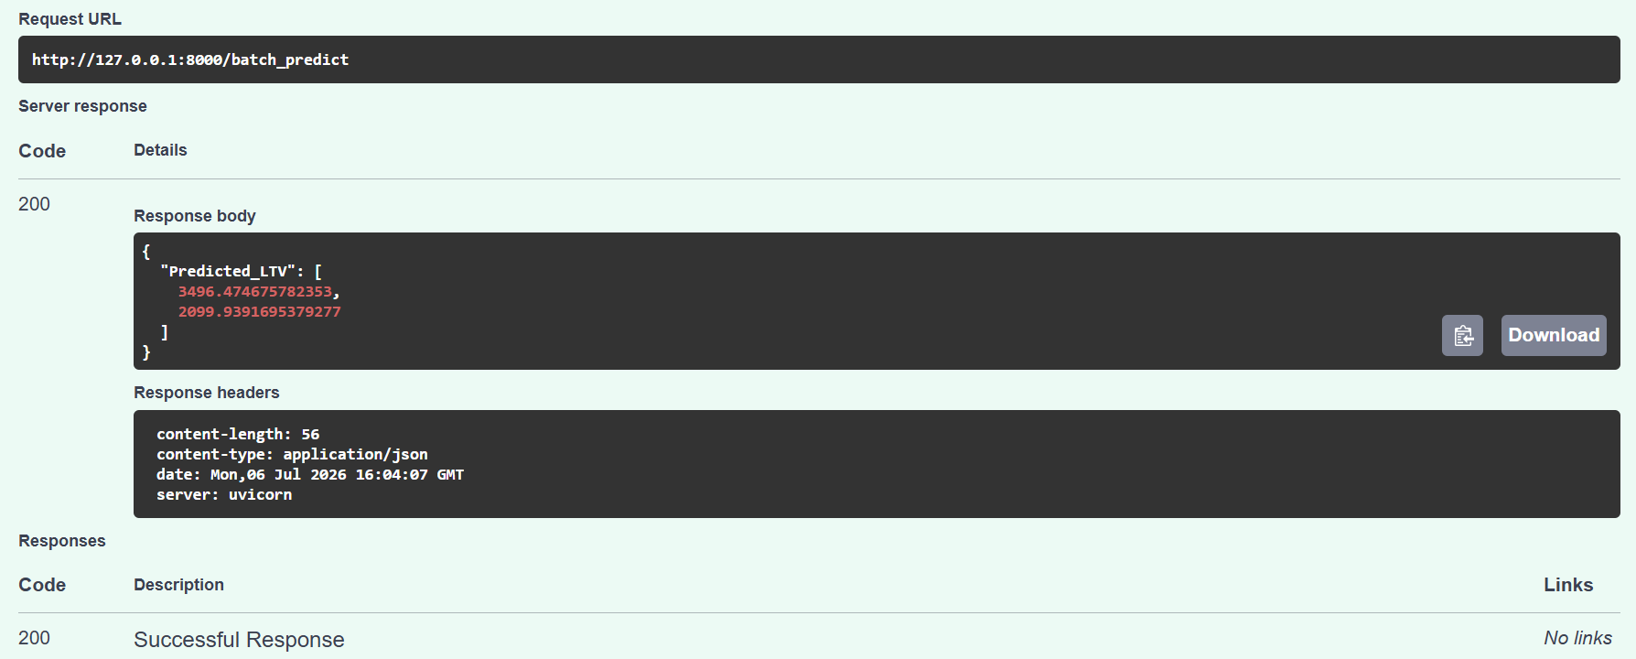

The Batch Prediction API was successfully tested using FastAPI by providing multiple customer records in a single request. The API processed both customer records simultaneously and returned the predicted Customer Lifetime Values (LTVs) of 3496.47 and 2099.94 with an HTTP 200 (Success) status code. This confirms that the batch prediction endpoint is functioning correctly and can efficiently predict the LTV for multiple customers in a single API request, making it suitable for large-scale customer analysis.
Conclusion
The FastAPI framework was successfully implemented to deploy the Customer Lifetime Value (LTV) prediction model as a web API. A Home API endpoint was created to verify that the application was running correctly. The Single Customer Prediction API successfully predicted the Customer Lifetime Value for an individual customer, while the Batch Prediction API efficiently processed multiple customer records in a single request. The APIs were tested using Swagger UI, and all endpoints returned successful responses. This project demonstrates how a Machine Learning model can be deployed as a real-time prediction service, enabling easy integration with business applications for customer analysis and decision-making.

